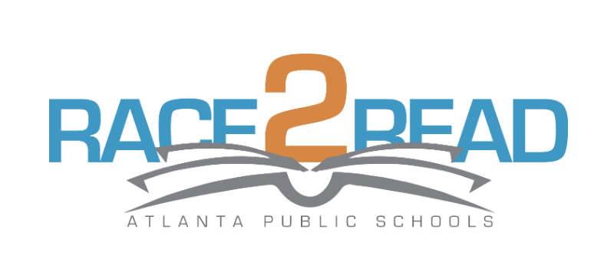
Atlanta Public Schools is raising the bar for reading via our district-wide APS Race2Read: The 2 Million Minutes Challenge! APS is challenging your child to read at least 20 minutes a day, five days a week.
As we Race2Read, we are creating a culture of engaged readers across APS. Read for pleasure, read to find out, read to defend a point of view, read to persuade, read to laugh, read to cry, read to understand. Read novels, newspapers, comics and more. Read, read, read anything! Just be sure to log your minutes.
LOGGING READING MINUTES
Your child has an account set up on our school’s Beanstack site: [mybackpack.apsk12.org] and look for RACE2READ 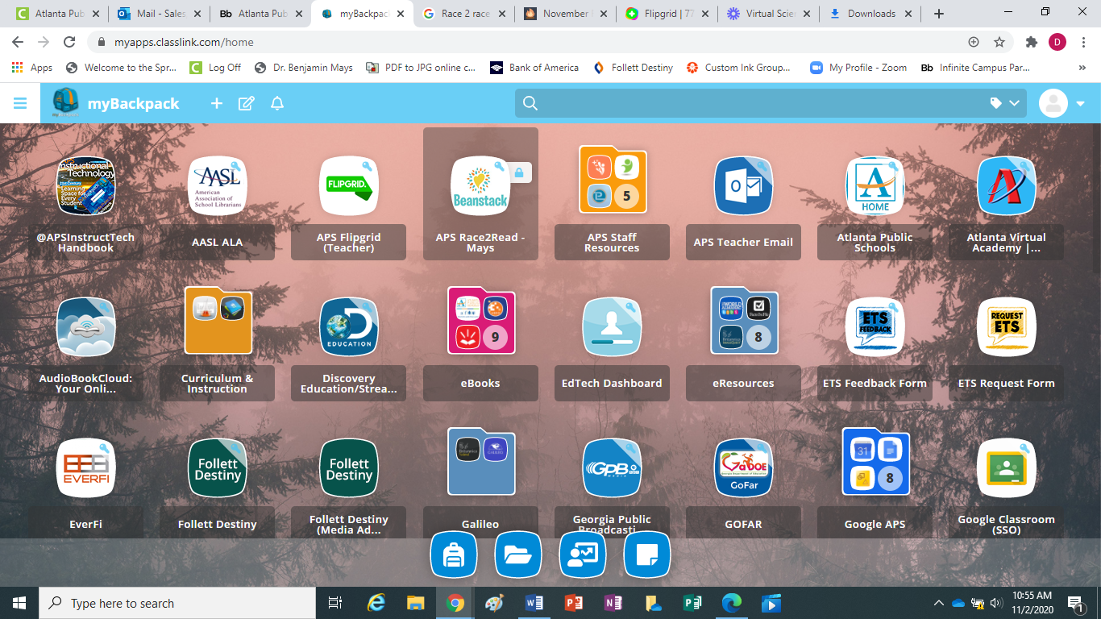
- Navigate to the site and select “Sign In”
- Your child’s login is his/her school username and the password is race2read
- As your child logs reading, he/she will earn virtual badges and special recognition

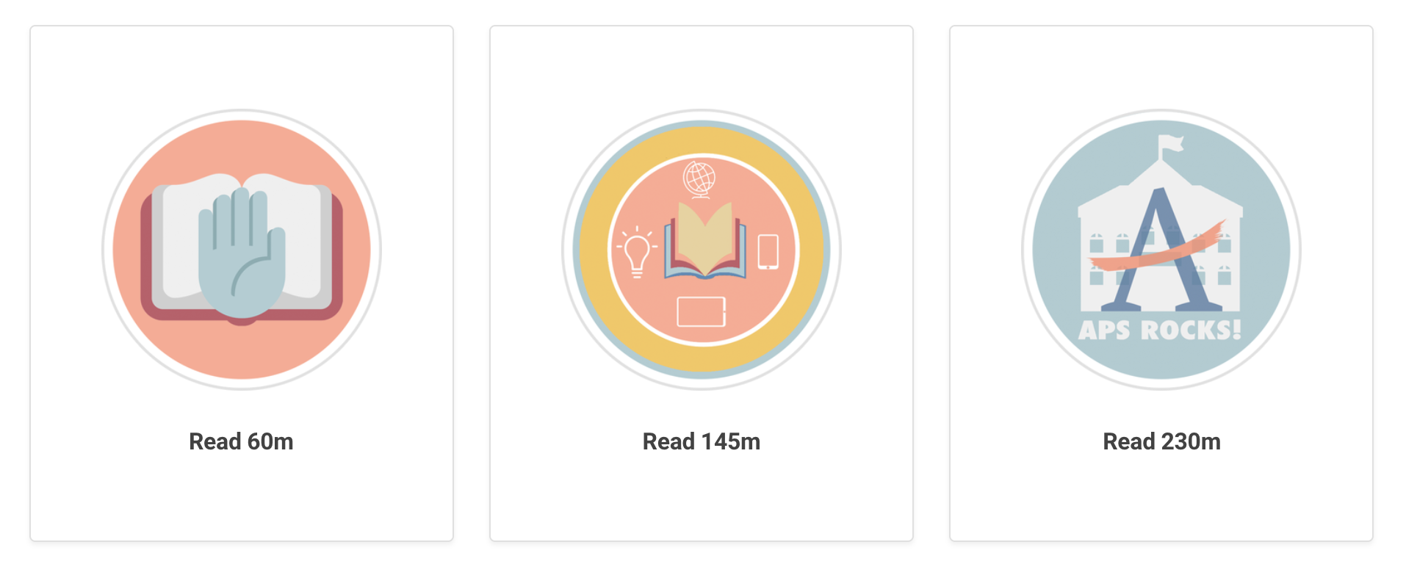
PARENTS & FRIENDS CAN JOIN THE RACE2READ TOO!
APS invites students, teachers, staff, parents and community partners to join us as we race to read a collective goal of 2 million minutes, and cross the finish line by the end of the 2018-2019 academic year! ​
Parents and friends (who are not enrolled in APS) can sign up to join the Race2Read at Race2Read.beanstack.org. Remember to attribute your minutes to your child’s school!
THERE IS ALSO AN APP FOR THAT!
- Visit the App Store or Play Store and download the Beanstack Tracker App
- Search for your child’s school and select it
- Sign in using the same login credentials
Here you may scan the books your child reads and more easily track (and time!) reading sessions!
For more information about the Race2Read, please contact [dsales@atlanta.k12.ga.us].

